BIO 101 Lab 06: Investigating Enzyme Activity

Notification: If you have a disability that makes it difficult to complete this lab, please contact your instructor. Please provide your instructor a copy of the Memorandum of Accommodation (MOA) from NVCC Disability Support Services.

Objectives:_________________________________________________________________

- Explain how enzymes facilitate chemical reactions
- Identify the substrate and product of catechol oxidase-catalyzed reaction
- Identify factors that affect enzyme activity

Background:________________________________________________________________

Within an organism there are innumerable reactions occurring at any given moment. Most of these reactions are carried out by enzymes. An enzyme is a protein molecule that acts as a catalyst for a chemical reaction. A catalyst is a chemical whose presence allows a reaction to occur much quicker and more easily than it would without it. The catalyst itself comes out of the reaction unaffected.

In any enzymatic reaction, the substrate attaches to the active site of the enzyme. This combination is called the enzyme-substrate complex. The substrate fits into the active site with high specificity. The interaction between substrate and enzyme causes a change to occur in the substrate molecule. Thus, the product is formed and exits the active site. If the enzyme causes the breakdown of a substrate, the reaction is an example of catabolism or a catabolic reaction. Enzymatic reactions may also combine two or more substrates into one product; this is anabolism or an anabolic reaction.

Today’s lab will focus on two different enzymes: catalase and catechol oxidase.

Catalase is an enzyme found in most living things. This enzyme catalyzes the conversion of hydrogen peroxide (H₂O₂) into water (H₂O) and oxygen gas (O₂). Conversion of hydrogen peroxide into other chemicals helps to protect cells from oxidative damage.

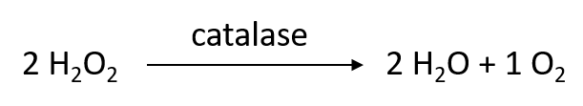

Catechol oxidase is an enzyme found in the chloroplasts of plant cells. This enzyme catalyzes the oxidation of catechol (a chemical stored in the vacuoles of plant cells) into benzoquinone. Benzoquinone is a red-brown substance that protects a damaged plant from infection and decay. When plant cells are damaged, the catechol in the plant cell vacuoles mixes with the catechol oxidase from the chloroplasts. This results in benzoquinone forming and is one of the reasons for the “browning” of cut fruits and vegetables.

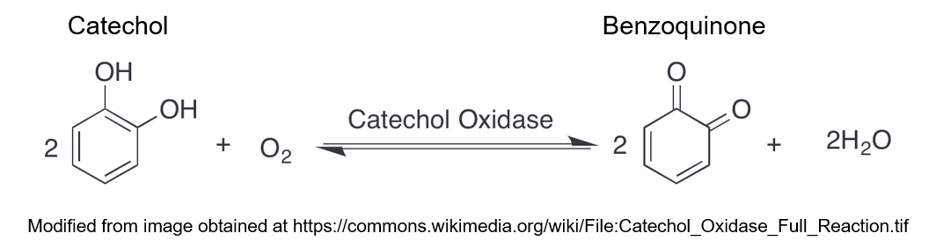

We will also be examining another chemical called hydroquinone, which is structurally similar to catechol, but is not the normal substrate for the catechol oxidase enzyme. A comparison of the chemical structures of catechol and hydroquinone is provided below.

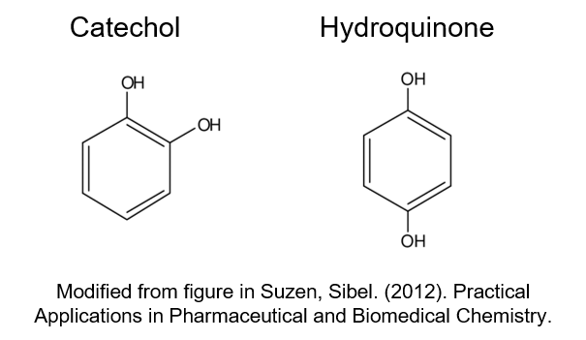

Enzymes require particular conditions to function effectively. These conditions include temperature, pH, and concentration of salt in the solution. When enzymes are exposed to conditions outside of their normal range, enzyme activity is decreased and the enzymes may even become denatured. A denatured enzyme has had its three dimensional structure changed in such a way as to make it non-functional. Typically, denatured enzymes will no longer function even if the enzyme is returned to conditions in its normal range

Safety:_____________________________________________________________________

Follow all standard laboratory safety procedures. Be sure to wear gloves when working with acids and bases.

Materials:___________________________________________________________________

- Internet

Procedure:__________________________________________________________________

Experiment 1 – Presence of Enzymes

- In the laboratory, you would obtain 5 small test tubes and mark each at 1 inch from the bottom of the tube. Then, you would fill each one to the mark with 3% hydrogen peroxide solution. Finally, you would place one “pea-sized” piece of mushroom into the first tube, one “pea-sized” piece of squash into the second tube, one “pea-sized” piece of banana into the third tube, a pinch of sand into the fourth tube and you would add 5 drops of distilled water to the fifth tube to be your negative control.

The experimental setup should look like this:

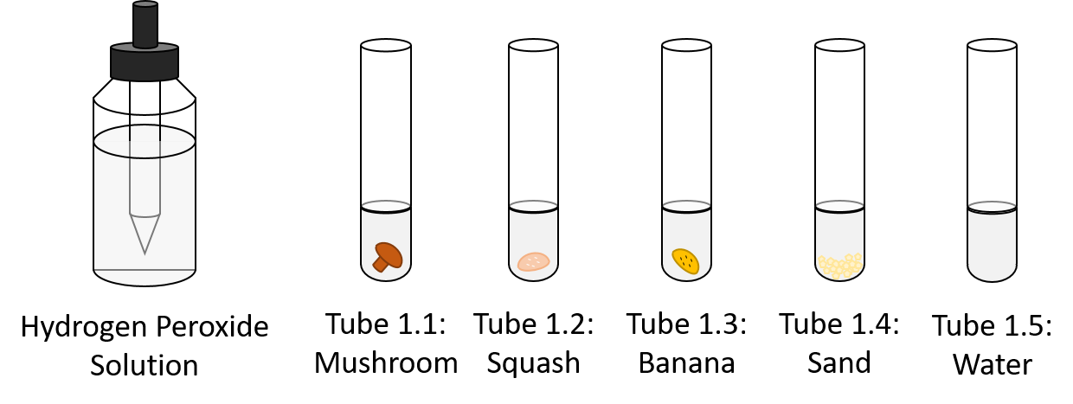

- You would then observe the changes (if any) in the solutions over a period of 5 minutes after adding the possible source of enzymes. You will then record your observations in Table 1.

The experimental results would look like this:

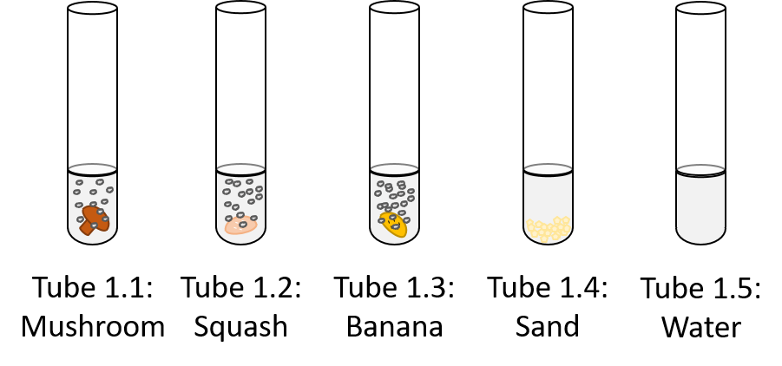

Experiment 2. Catechol oxidase enzymatic activity and effect of substrate structure on enzymatic reactions

- In the laboratory, you would obtain and label four test tubes 1 – 4. Using a disposable 1.0 mL transfer pipet, you would then add 1 mL of water to each tube. After this, you would add 10 drops of water to Tube 1, add 10 drops of catechol to Tube 2, add 10 drops of catechol to Tube 3 and add 10 drops of hydroquinone to Tube 4. Finally, you would add 5 drops of potato extract into Tubes 3 and 4. You would then place all three test tubes into a tube rack on your lab table (room temperature).

The experimental setup should look like this:

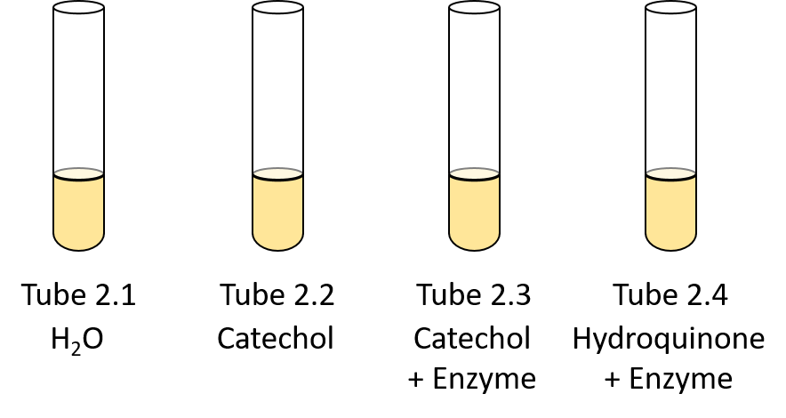

- Record the initial color of each tube in Table 2.

- You would then observe the color of each tube every five minutes and record the color changes in Table 2. You would continue doing this for a total of 15 minutes

The tubes would look like this:

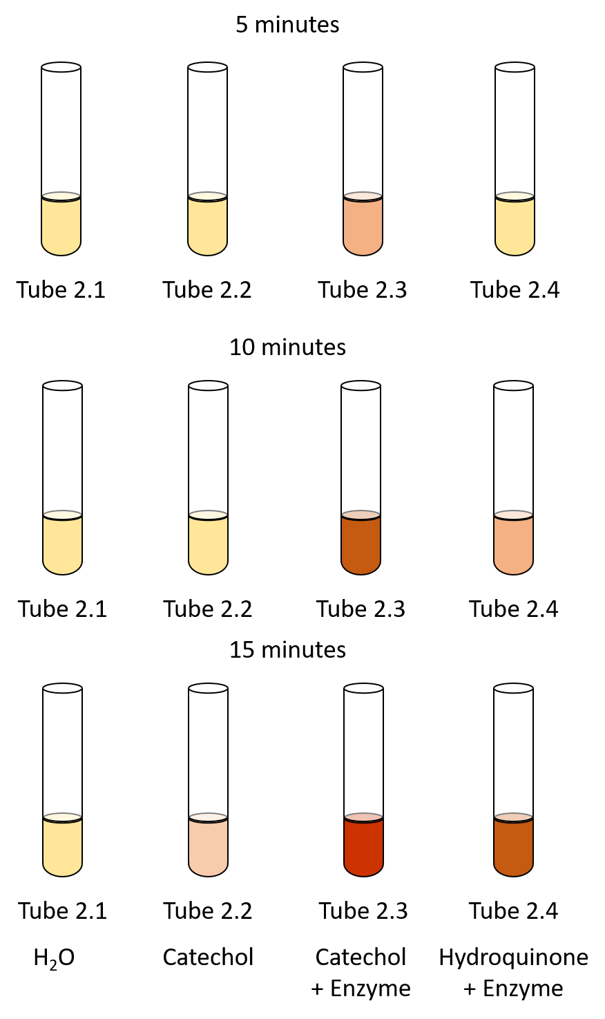

Experiment 3. Effect of temperature on enzymatic reaction

- In the laboratory, you would obtain four test tubes and label them 1-4. Using a disposable 1.0 mL transfer pipet, you would then add 1 mL of water to each tube. After this, you would add 5 drops of potato extract into each tube.

- You would then place Tube 1 on ice (approximately 0 °C), Tube 2 in a tube rack on your lab table (room temperature, approximately 20 °C), Tube 3 in a 40 °C warm water bath (or incubator), and Tube 4 in a 80 °C hot water bath. Make sure to record the temperatures of the ice, the room, and the water baths in Table 4.

- You would then incubate the tubes in their respective temperature incubation conditions for five minutes.

- After this, you would remove the tubes from their incubation conditions and add 10 drops of catechol to each tube. Then, you would record the initial color (time zero) of each tube in Table 3.

The experimental setup should look like this:

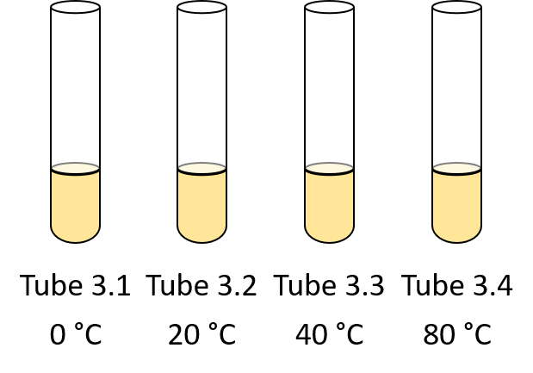

- After recording the initial colors, you would return the tubes to their designated incubation conditions (see step 2). Every five minutes, you will then check and record the color of each tube in Table 3. You will continue this process for a total of 15 minutes.

The tubes would look like this:

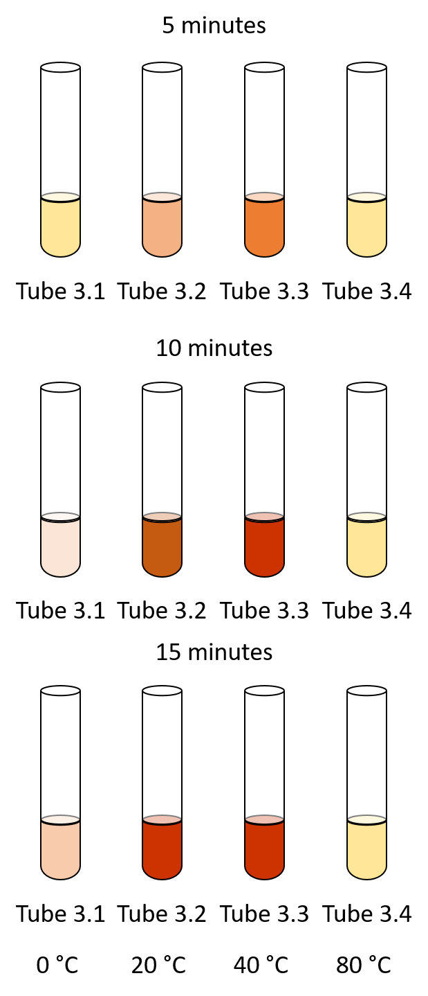

Experiment 4. Effect of pH on enzymatic reactions

- In the laboratory, you would obtain and label five test tubes 1-5. Using a disposable 1.0 mL transfer pipet, you would then add 1 mL of water to each tube. Next, you would add 5 drops of potato extract into each tube.

- You would then add 3 drops of HCl solution and 7 drops of water to Tube 1, 1 drop of HCl solution and 9 drops of water to Tube 2, 10 drops of water to Tube 3, 1 drop of KOH solution and 9 drops of water to Tube 4, and 3 drops of KOH solution and 7 drops of water to Tube 5.

- Finally, you would add 10 drops of catechol into each tube, place all three tubes in a tube rack on your lab bench, and record the initial color of each tube (time zero) in Table 4.

The experimental setup should look like this:

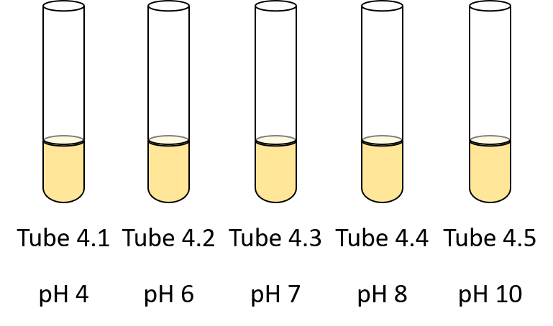

- Check and record the color of the solutions in Table 4 every five minutes for 15 minutes.

The tubes would look like this:
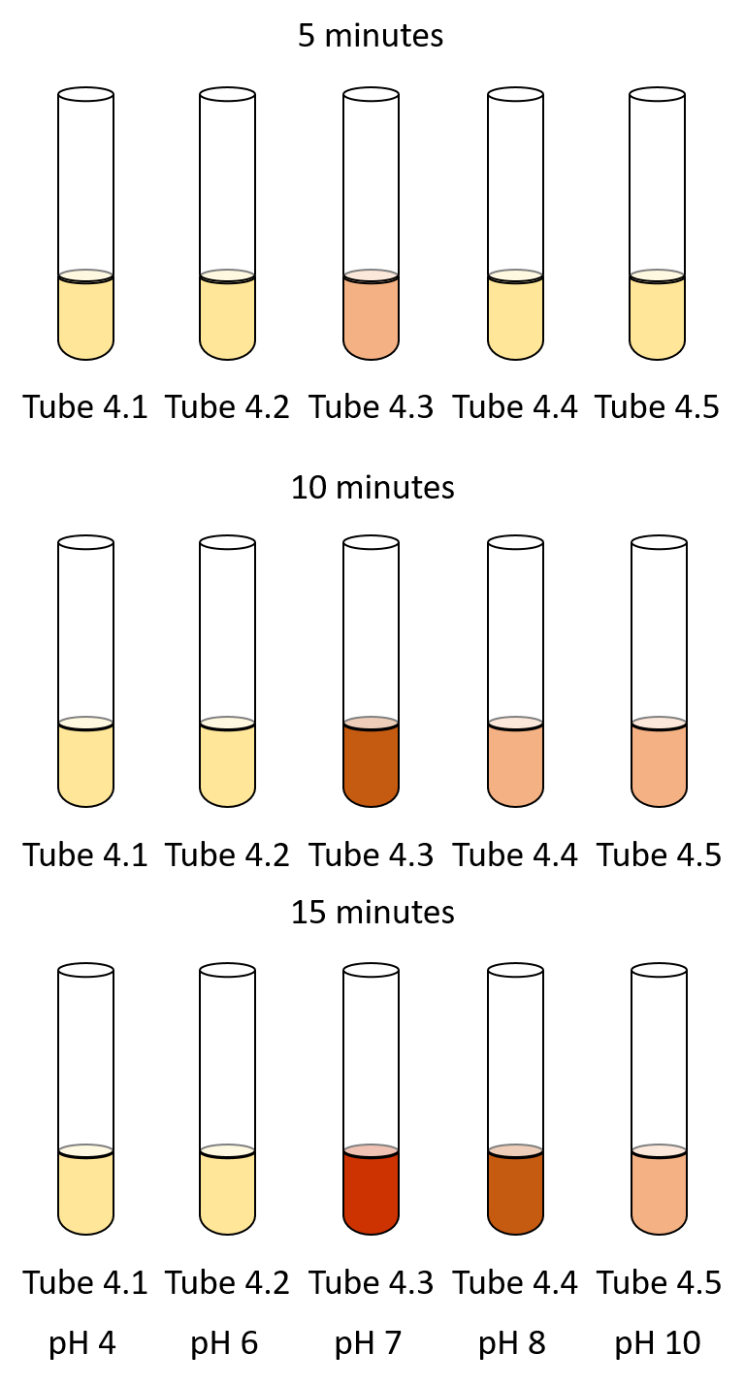
BIO 101 Lab 06: Investigating Enzyme Activity Lab Worksheet

Name: __________________________ Section: ______________________

Data Analysis and Synthesis Questions:

Table 1. Presence of catalase in food samples
Tube | Tube 1.1 Mushroom | Tube 1.2 Squash | Tube 1.3 Banana | Tube 1.4  Sand | Tube 1.5  Control
Observations

Did it contain enzymes that react with hydrogen peroxide?
(yes/no)

Table 2. Color of solution observed in each tube as a result of catechol oxidase enzymatic activity using different substrates
Time (in minutes) | Tube 2.1  H₂O | Tube 2.2  Catechol | Tube 2.3  Catechol  + Enzyme | Tube 2.4  Hydroquinone + Enzyme
0 (initial color)
5
10
15

Graph 1. Bar Graph of Enzyme Activity in the presence of different Substrates



Table 3. Color of solution observed in each tube as a result of enzymatic reactions at different temperatures
Time (minutes) | Tube 3.1 | Tube 3.2 | Tube 3.3 | Tube 3.4
Time (minutes) | _____°C | _____°C | _____°C | _____°C
0
5
10
15

Graph 2. Line Graph of Temperature versus Absorbance at 520 nm

Table 4. Color of solution observed in each tube as a result of enzymatic activity in different pH conditions
Time (minutes) | Tube 4.1  pH 4 | Tube 4.2  pH 6 | Tube 4.3  pH 7  (Control) | Tube 4.4  pH 8 | Tube 4.5  pH 10
0
5
10
15

Graph 3. Bar Chart of Enzyme Activity at Different pH

- In Experiments 2, 3, and 4, what is the source of enzyme?

- In Experiment 2, what is the purpose of Tubes 2.1 and 2.2?

- In Experiment 2, when comparing Tube 2.3 and Tube 2.4:

  - Which tube changed color from light yellow to red-brown the fastest?

  - Explain the results.

- Based on the results of Experiment 3:

  - What is the optimum temperature for the function of catechol oxidase?

  - Explain what happened to the enzyme in the 80⁰C water bath.

- Based on the results of Experiment 4:

  - Does catechol oxidase work efficiently at low pH?

  - Explain why squeezing lemon juice on a cut potato can slow down the tissue browning of the potato.

